Much Ado About Nothing Act 2, scene 2 formative feedback and example
- Kids do 2.2 formative in class. Have kids write it for 13 minutes, then draw a line on the page, then show feedback about this formative from 2014 and have them rewrite it:
  - Pay attention to details (like what Borachio/DJ are the bad guys and Margaret and Hero are naïve)
  - Follow directions: be sure to answer the question (this is not a summary of the plan) and write in 3rd person/past tense
  - Have a clear topic sentence. It should sound something like, “Shakespeare used a simile to convince his audience that Borachio’s plan will work.”
  - Use specific text evidence to prove your claim. Be sure to accurately identify a specific literary device and cite (meaning copy and put in quotation marks) exact words from the text (words Shakespeare wrote) that support your topic sentence.
  - For evidence gathering, you can use “text as a whole” author’s craft things too, such as “Don John is the antagonist and he even said ‘I am a plain-dealing villain’ so his plan will work because this will create the conflict of the story because there is no real conflict yet.”
  - For analysis, keep in mind that this is a comedy and that it is eventually going to end with great mirth. However, this is only act 2. This shows an understanding of the text as a whole if you can think this way. This is shown in the picture below

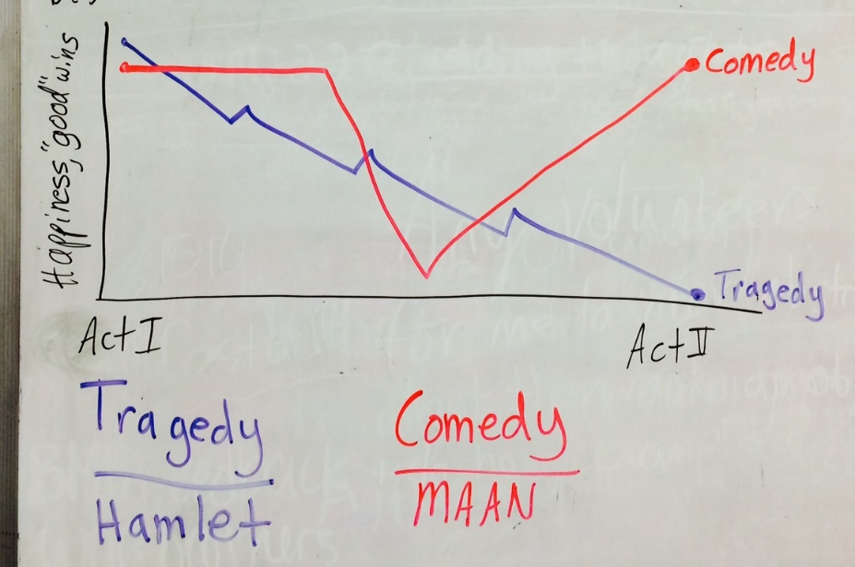

For this paragraph, as is the case with all analysis paragraphs, you need a claim, evidence and analysis (how the evidence proves the claim). Below is a color coded exemplar.

Shakespeare made it clear to the audience that Borachio’s plan would work through the use of hyperbole. At the beginning of the act II, scene ii, after hearing that Borachio had a plan, Don John proclaimed, “any bar, any cross, any impediment will be medicinable to me.” Here, Don John is saying that he craves any mischief that will ruin the marriage between Claudio and Hero. Specifically, he is using hyperbole by repeating the words “any.” This is hyperbole because he is exaggerating his desire to do ANYthing that will cause harm. This makes Shakespeare’s claim very clear. For example, when the author had Don John use hyperboles, he used exaggeration to show Don John’s commitment to the plan. Don John would do “any”thing to make this plan happen. The dedication of Don John’s villainy is very clear through this hyperbole; nothing will stop him. Borachio’s plan has a strong likelihood of succeeding when one of its participants is so adamant about making the treachery happen. Therefore, it is obvious to the audience that Borachio’s plan will have success when coupled with Don John’s hyperbolic sincerity in being the antagonist.

