Review this chart with the students before doing this activity
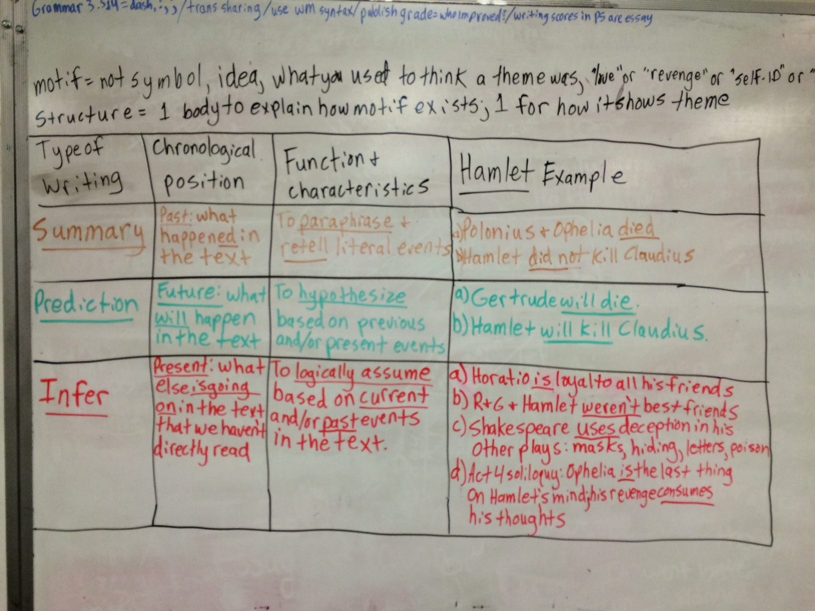

If they are having trouble, give them these examples:
- In the text, right now, just based on this soliloquy: “I can logically infer that Hamlet’s ghost dad is disappointed in Hamlet because…”
- In the text as a whole, big picture, but also using the thoughts from this soliloquy as a guide: “I can logically infer that Claudius favors power and lust over family because he killed his brother in order to obtain his brother’s crown and woman, respectively.”

Hamlet Act IV, scene iv Paraphrasing and Inferring practice
Watch the amazing Mr. Foster thespiainize the heck out of the soliloquy in this scene, and watch David Tenet do it better at https://www.youtube.com/watch?v=UOkImi8n0Os at 1:18 and watch an engaging version of the text at https://www.youtube.com/watch?v=FM2SUBtD3qA then…
Thoughts I KNOW Hamlet is having | Words from the text that support it
Overall mindset of Hamlet for 1.0 minimum: | One accurate text support for this thought for 1.0 minimum:
One specific example of his overall mindset for 2.0 minimum: | An additional, unique accurate text support for this thought for 2.0 minimum:
Another unique, specific example of his overall mindset for 3.0 minimum: | An additional, unique accurate text support for this thought for 3.0 minimum:
Another, unique specific example of his overall mindset 4.0 minimum: | An additional, unique accurate text support for this thought for 4.0 minimum:
Inference(s) I can now make about Hamlet and Hamlet
Sure you can easily infer Hamlet is upset. However, what else? Logically infer what he is also feeling, or not feeling, at this time as well. Or, better yet, infer what this soliloquy and the brilliant thoughts you wrote in the chart above mean for the play Hamlet as a whole.

Learning Target | 4.0 | 3.0 | 2.0 | 1.0
Cite and explain accurate and relevant evidence to support claims and/or counter claims | I can use an abundance of  evidence that is reliable,  specific, relevant,  unbiased & directly proves  my thesis beyond teacher  expectations. | I can use a supply of  evidence that is respectable,  specific, useful, unbiased  and proves the thesis. I do  this consistently for every  argument/reason. | Some evidence I used is  helpful, relevant, unbiased  and works to prove the  thesis. I am sometimes  inconsistent or inaccurate  with my argument support | I used little to no evidence;  it is unreliable, vague,  irrelevant, biased,  plagiarized and/or doesn’t  directly prove the thesis. I  require teacher help to show  evidence for arguments
Analyze inferences while reading fiction & nonfiction | I can insightfully explain at least  3 inferences I made-the majority  of which explain the text as a  whole and/or address accurate  concepts we never covered | I can plainly explain several examples  Of inferences relatively accurately &  consistently. I made it clear that my  inferences address the text as a whole. | I can mention some examples  of inferences somewhat  accurately and consistently. I  merely hinted at or implied  the text as a whole | I can partially identify a few examples of  inferences with some inaccuracies & teacher help. I have no mention of the text as a whole.
Student Name:
Sparknotes Act 4, scene 4
On a nearby plain in Denmark, young Prince Fortinbras marches at the head of his army, traveling through Denmark on the way to attack Poland. Fortinbras orders his captain to go and ask the King of Denmark for permission to travel through his lands. On his way, the captain encounters Hamlet, Rosencrantz, and Guildenstern on their way to the ship bound for England. The captain informs them that the Norwegian army rides to fight the Poles. Hamlet asks about the basis of the conflict, and the man tells him that the armies will fight over “a little patch of land / That hath in it no profit but the name” (IV.iv.98–99). Astonished by the thought that a bloody war could be fought over something so insignificant, Hamlet marvels that human beings are able to act so violently and purposefully for so little gain. By comparison, Hamlet has a great deal to gain from seeking his own bloody revenge on Claudius, and yet he still delays and fails to act toward his purpose. Disgusted with himself for having failed to gain his revenge on Claudius, Hamlet declares that from this moment on, his thoughts will be bloody.

Analysis: Act IV, scenes iii–iv
As we saw in Act IV, scene ii, the murder of Polonius and the subsequent traumatic encounter with his mother seem to leave Hamlet in a frantic, unstable frame of mind, the mode in which his excitable nature seems very similar to actual madness. He taunts Claudius, toward whom his hostility is now barely disguised, and makes light of Polonius’s murder with word games. He also pretends to be thrilled at the idea of sailing for England with Rosencrantz and Guildenstern.
On some level he is prepared for what is to come. His farewell to his mother proved as much, when he told her that he would trust his old schoolfellows as if they were “adders fang’d,” that is, poisonous snakes (III.iv.185.2). But although Hamlet suspects his friends’ treachery, he may not fully realize the malevolence of Claudius’s designs for him. Claudius’s subterfuge in asking the English to execute Hamlet reveals the extent to which he now fears Hamlet: whether Hamlet is sane or mad, he is a danger to Claudius, and Claudius wishes him to die. It is also revealing that one of Claudius’s considerations in seeking to have Hamlet murdered in far-off England, rather than merely executing him in Denmark, is that he is beloved by the common people of Denmark—“loved of the distracted multitude,” as Claudius says (IV.iii.4). Again, where King Hamlet was a brave warrior, King Claudius is a crafty politician, constantly working to strengthen his own power, circumvent threats to his throne, and manipulate those around him to his own advantage.
Act IV, scene iv restores the focus of the play to the theme of human action. Hamlet’s encounter with the Norwegian captain serves to remind the reader of Fortinbras’s presence in the world of the play and gives Hamlet another example of the will to action that he lacks. Earlier, he was amazed by the player’s evocation of powerful feeling for Hecuba, a legendary character who meant nothing to him (II.ii). Now, he is awestruck by the willingness of Fortinbras to devote the energy of an entire army, probably wasting hundreds of lives and risking his own, to reclaim a worthless scrap of land in Poland. Hamlet considers the moral ambiguity of Fortinbras’s action, but more than anything else he is impressed by the forcefulness of it, and that forcefulness becomes a kind of ideal toward which Hamlet decides at last to strive. “My thoughts be bloody, or be nothing worth!” he declares (IV.iv.9.56). Of course, he fails to put this exclamation into action, as he has failed at every previous turn to achieve his revenge on Claudius. “My thoughts be bloody,” Hamlet says. Tellingly, he does not say “My deeds be bloody.”

