Graphing Reading Comprehension-Romeo & Juliet, Act I, scene iii
First, read page 1052. As you read, fill out the boxes below. Second, use what you wrote in the boxes below to make a graph that charts the annoyance of Juliet’s mom (Lady Capulet) in the scene. The x-axis represents the chronology of the text: the left is the first line, and the right is the final line. Label this axis clearly. The y-axis represents the severity of the annoyance: the bottom is “not annoying,” and the top is “very irritating.” Label this axis clearly. After plotting the points on the graph, connect the dots to make a line graph.
Plot point number | Thing parents do sometimes | Line numbers and direct quote where Juliet’s Mom does this on page 1052 (these go in chronological order) | Your opinion of how annoying this is (scale 1-10, 10 is the most annoying)
1 | Asks you about your love life and your goals in that area of life
2 | Using “when I was your age” as an excuse for something they want you to do
3 | Trying to set you up romantically with someone they think is right for you
4 | Offering a lot of compliments about the person they want to set you up with
5 | Asking for your honest opinion about the person they want to set you up with

How annoying is Lady Capulet in act I, scene iii of Romeo and Juliet?
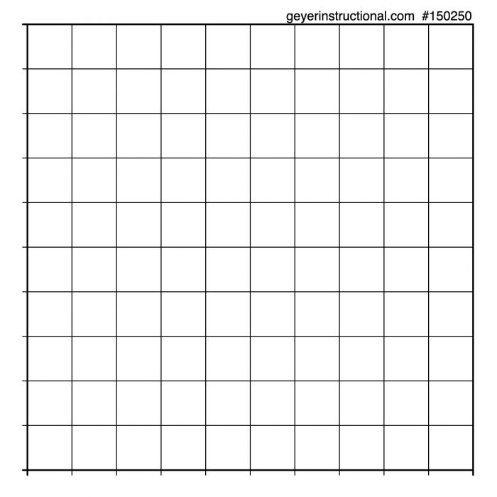

Now your task is to use the information from the boxes and graph to do one of two writing options: a TADA paragraph answering the question, “Is Lady Capulet annoying in this scene?” OR writing a letter to one of your grownups explain how he/she is more or less annoying than Lady Capulet. Regardless of which option you choose, in your response include at least one direct quote from the text formatted in MLA: For example, when she states, “Find beauty written in the margen of his eyes,” Lady Capulet is annoying (Shakespeare 1052).
Use this QR code as a resource to help with MLA documentation:

Feedback for this task:
Next Steps:
I consistently or sometimes or struggle to literally understand a text & cite text words to show my understanding.
(Circle the phrase that fits) Log these words in Feedforward under one of the “Reading Micro” tasks.
I consistently or sometimes or struggle to use multiple analysis sentences that say how my evidence proves my claim.
(Circle the phrase that fits) Log these words in Feedforward under one of the “Writing Macro” tasks.
I consistently or sometimes or struggle to follow grammar rules to clearly express my message.
(Circle the phrase that fits) Log these words in Feedforward under one of the “Writing Micro” tasks.
I consistently or sometimes or struggle to use MLA documentation to incorporate “research” into my writing.
(Circle the phrase that fits) Log these words in Feedforward under one of the “Writing Micro” tasks.
I consistently or sometimes or struggle to use varied & mature syntax & diction in my writing.
(Circle the phrase that fits) Log these words in Feedforward under one of the “Writing Micro” tasks.

