One of Mr. Foster’s obligations is that you receive information about a major text of literary merit before you read it. However, it is boring to hear him lecture and PowerPoint/Prezi slides are not very interactive. Therefore, today we are going to jigsaw, collaborate and synthesize. Step one in the group (of three people that Mr. Foster assigns you) is to choose a subsection below, use the websites under that subsection and fill in your blanks. Step Two is delineated below.
Shakespearean Biographical Sketch
http://www.bardweb.net/man.html http://www.shakespeare-online.com/keydates/playchron.html
- From what two sources do we get our information about Shakespeare’s early life ?
________________ ____________________________ and _____________________________________________________
2. Allegedly, Shakespeare’s birthday was _______________. “Allegedly,” most likely means:
a) Accordingly
b) Presumably
c) Eventually
d) Precisely
4. What school did Shakespeare most likely attend? Why is it logical to infer that he attended this school?

__________________________________________________________________________________________________________________________

5. Two rumors surrounding what Shakespeare was doing during his “Lost Years”: _____________________________________________________________________________________________________________________________,

and ______________________________________________________________________________________________________________________

6. Shakespeare’s accomplishments became apparent when they were ____________________________________________________________________________________________________________________________

7. What did Shakespeare get to enjoy that no other playwright had ever experienced? ____________________________________________________________________________________________________________________________

8. Which play of Shakespeare’s was performed first? _______________________ Which play was performed last? ____________________________

9. What year was Hamlet first acted? _____________ Published? __________________
10. Shakespeare spanterly died in the year: ________________ “Spanterly,”means:
a) Deadly
b) Allegedly
c) Vitally
d) Intently
Effects of Shakespeare
http://www.shakespearehigh.com/classroom/guide/page1.shtml http://www.shakespeare-online.com/biography/whystudyshakespeare.html
http://www.shakespeare-online.com/biography/shakespearewriter.html
1. Did people really talk the way Shakespeare wrote his words? Why did he write them this way?

__________________________________________________________________________________________________________________________

2. For the sake of his poetry, Shakespeare often left out _____________________, ______________________, and ___________________________.

3. Four reasons behind Shakespeare’s influence and popularity: ___________________________________, ______________________________, __________________________________________, and __________________________________________________.

4. Three of Shakespeare’s most popular phrases: _________________________________________________________________________________,

_________________________________________________________, and ____________________________________________________________

5. Many pieces of literature are heavily influenced by Shakespeare’s works. Some are even different versions of, or ANALOGUES of, Shakespearean works. Using context clues to understand the term “analogue,” complete the chart below.

Analogue (Literature) | Shakespearean Work | Most prominent similarity

6. Many movies are heavily influenced by Shakespeare’s works. Some are even different versions of, or ANALOGUES of, Shakespearean works. Using context clues to understand the term “analogue,” complete the chart below.
Analogue (Film) | Shakespearean Work | Most prominent similarity

Criticisms of Shakespeare
http://www.debate.org/opinions/should-shakespeare-be-taught-in-schools http://www.infoplease.com/encyclopedia/people/shakespeare-william-critical-opinion.html
http://www.newworldencyclopedia.org/entry/William_Shakespeare
1. After reading several reasons against teaching Shakespeare in school, pick the most prominent, valid reasons. Rank them according to validity below
Most valid: __________________________________________________________________________________________

Second: __________________________________________________________________________________________

Third: __________________________________________________________________________________________

2. What was early criticism of Shakespeare directed at? ____________________________________________
3. Shakespeare was criticized for mixing ________________________________ and ________________________________ and also failing to ____________________________________________________________________________________________________________

4. Some critics, such as Dryden and Johnson, claimed that Shakespeare __________________________________________________
5. Generally, critics of the 17th and 18th century accused Shakespeare of __________________________________________________________________________________________________________________________________
6. After reading several speculations against teaching Shakespeare according to New World Encyclopedia, pick the most valid speculation. Rank them according to validity below:
Most valid: __________________________________________________________________________________________

Second: __________________________________________________________________________________________

Third: __________________________________________________________________________________________
Step Two: Now that you have gathered information individually, write a synthesis statement that best encapsulates your information below. Then, share only the most potent, pertinent and key information with your group to arrange this information (from all three group members) in a logical, effective manner. The overall goal is to examine how this information (from all three group member) is related, choose a graphic organizer that works for your group, and arrange just the most critical information in the graphic organizers that you chose. Below are resources for graphic organizers. You can download one digitally and type your responses and then print OR you can download one digitally and print and hand write your responses OR review the graphic organizers and choose the most best fit for your group and draw a version of it with your hand and fill in information.

Graphic Organizer Resources
- https://www.google.com/search?q=graphic+organizers&rlz=1C1CHWA_enUS601US601&espv=2&biw=1920&bih=971&tbm=isch&tbo=u&source=univ&sa=X&ei=xXE-VNuEGcu7ggTXkYD4Dg&ved=0CC8QsAQ
- http://www.enchantedlearning.com/graphicorganizers/
- http://edhelper.com/teachers/graphic_organizers.htm
- http://edudemic.com/2012/education-mind-maps
- http://www.eduplace.com/graphicorganizer/
- http://go.hrw.com/hrw.nd/gohrw_rls1/pKeywordResults?btm%20graph
- http://printables.scholastic.com/printables/detail/?id=35517

Step Three: After you wrote your synthesis statement below, shared your information with your group and created one graphic organizer per group, review the information (from all three groups), and, individually, write one concise, yet potent thesis statement about Shakespeare that encompasses all of the information your group gathered.

When you are finished, turn in the following items in the following order: your individual thesis statement that synthesizes your information, your group’s completed graphic organizer with all of your names on it (only one member per group will turn this in), your whole group synthesis statement, this page for each with a self-graded rubric, & your hopes and dreams.

My name:
My individual thesis that synthesizes all of the information I gathered. This synthesis statement is summative and uses a colon effectively for a 3.0. A 3.5-4.0 score will have a thorough explanation of why this thesis works.

My group’s graphic organizer is either attached or
drawn below or one of my group members turned it in for me (circle one)

The whole group synthesis statement that summarizes all of the information in our graphic organizer is below:

Learning Target | 4.0 | 3.0 | 2.0 | 1.0
Purpose = Did I produce clear writing to accomplish a specific purpose: to persuade, to inform, to analyze, and/or to entertain? | I can make my purpose very clear beyond teacher expectations. My reader is completely familiar with my claim in a profound way. | I can make my purpose clear consistently. My reader is pretty familiar with my claim. My purpose is apparent and believable. | I can make my purpose fairly clear. My reader is somewhat familiar with my claim. Some aspects of my purpose are confusing or unclear. | I struggle to make my purpose obvious. My reader is not clear about my claim. I require teacher assistance to clarify a purpose in my writing.
Here is an example of how a student performed well on this assessment last year:

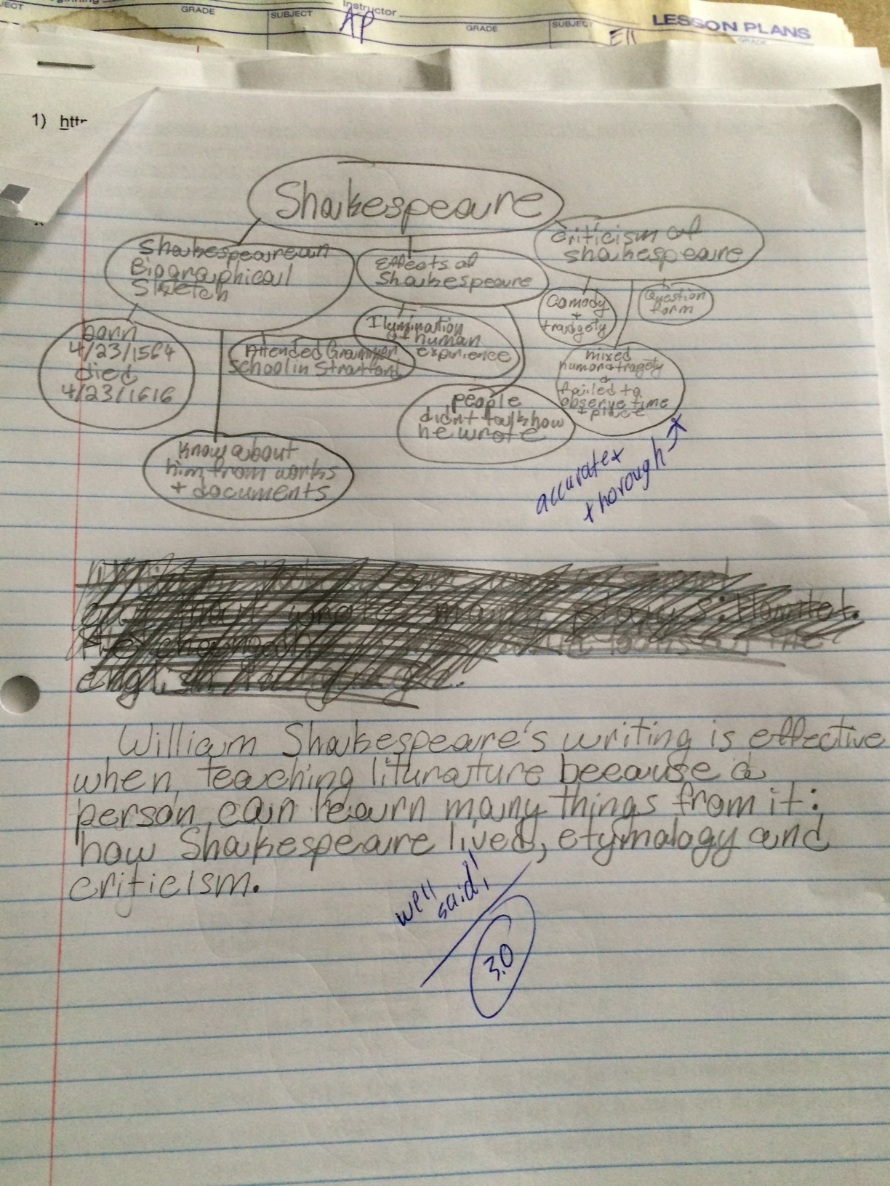

The 3.0 score reflects proficiency in “Accomplish the writing Purpose.” This student accurately and concisely synthesized/paraphrased/summarized all of the research that this student’s group put in the graphic organizer. This student has a few misspelled words (literature, criticism, etc), but this was not assessed on “grammar.” Also, this student should probably improve the diction of “things,” but again, this was not assessed on “diction”-only “Purpose”.

