Nicole Ewert

Selected Response Assessment for 2nd Grade English/Language Arts

**Unit:** Sentence Composition

**Grade:** 2nd

**Purpose:** During this ungraded formative assessment, second grade students will display their knowledge and understanding of sentence composition. Throughout this assessment, students will use the proper structure in creating sentences as well as show their understanding of detail and clarification. The instructor will evaluate the students’ understanding of sentence structure through a series of true and false, fill in the blank, and multiple choice questions. This assessment will allow students to label the main components of a sentence: verbs, nouns, and adjectives. One section of the assessment will also involve a listening component where students can test their knowledge in recalling certain parts of speech within a given sentence. Students will recognize their level of understanding of this focus area throughout this assessment, and with a self assessment they will acknowledge areas in which they may need improvement. The instructor can also compile results from the students’ self assessments, and utilize the data to better the students’ knowledge and understanding by focusing on what needs improvement rather than the concepts that are close to mastery.

**Standards/Benchmarks:**

* SL.2.6. Produce complete sentences when appropriate to task and situation in order to provide requested detail or clarification.

|  |  |  |
| --- | --- | --- |
| **Learning Targets** | **Knowledge Item #** | **Reasoning Item #** |
| I can locate a complete sentence. | 13,16,17,19 |  |
| I can classify the difference between verbs, nouns, and adjectives. |  | 11,12,14,15,  18,19,20 |
| I can recognize correct spelling. | 1,2,3,4,5 |  |
| I can name verbs and adjectives. | 1,2,3,4,5,6,7,8,9,10,  12,14,15,18,20 |  |
| I can identify errors within sentences. | 13,16,17,19 |  |

*Because this is a second grade class, I will read all of the following directions out loud to the class. I wanted to be detailed in my directions, and I realize that it may be too much for second graders to read on their own.

**Assessment Directions ☺**

In class we have been reading many books aloud. The past few days we have really been focusing on all of the detail within the books we are reading. Details like colors, heights, weather, and even moods. You all seem to be doing a wonderful job picking out the words that bring detail into books. Today your job is to put your thinking cap on and think all the way back to the beginning of the year when we learned how to write sentences. I am going to ask you to show me, and yourself how well you can write sentences that will now include some detail. This will help you to see how well you can recall how to write sentences, what needs to be included within a sentence, and how to write an even better sentence with describing words called ADJECTIVES.

* **Part 1:** Part 1 is the Fill in the Blanks portion of the assessment. During this section you will be asked to first listen to the teacher read 5 sentences out loud. As they are read aloud, it is your job to fill in the blanks. After the listening section, there will be 5 more Fill in the Blanks questions that you must fill in after reading the sentences on your own.
* **Part 2:** Part 2 is the True and False section of the assessment. You will need to read the 5 statements given, decide if you would identify them as TRUE or FALSE, and then circle the answer you feel best fits the statement. This section will be used to test your basic knowledge of sentence composition.
* **Part 3:** Part 3 of the assessment is the Multiple Choice section. On this part of the assessment you will be given 5 multiple choice questions. You will be asked to read each question all of the way through, and then out of the 4 possible answers given, you will need to choose the correct one.
* After you complete each of questions, you will see two check boxes, one titled SURE, and one titled UNSURE. Please put an ‘X’ inside the box that describes the way you felt about your answer for that question. ☺ This will help us to go over information that still is confusing as a class! And remember, marking SURE or UNSURE will not affect your grade. It’s just to help me understand which material needs to be reviewed further.

**Before We Get Started…**

1. Remember this is not graded, so there is no need to worry, just try your hardest, and show me the best you can do! ☺
2. Please write your name in the upper left hand corner of the first page of your assessment.
3. Read all of the questions entirely before coming up with an answer.
4. Most importantly…TAKE YOUR TIME ☺ You will be given 40 minutes to complete this assessment, but if I feel that the class needs more time, I will make sure that more time is given ☺
5. If you have any questions, raise your hand, and I will be right over to your desk to help you ☺
6. Please remember to mark either SURE or UNSURE for each question.
7. When you are finished with your assessment, please flip your assessment over and quietly work on something at your desk. We don’t want other friends to worry that they’re not finished yet ☺



**Flip to page 1 to begin the listening portion…**

**NAME:____________________**

**Part 1: Fill in the Blanks + Listening**

**Directions:** Listen carefully as I read the following 5 sentences out loud. You are listening for the missing verb in the below sentences. I will read each sentence two times, and if you need it repeated please raise your hand. When you have recognized the missing verb, write the verb on the correct blank line. Please remember to mark whether you are SURE or UNSURE of each problem.

*I will then begin to read the following 5 sentences aloud. It is important for students at this level to not only be able to understand components of sentences when writing, but also to be able to distinguish those components when listening and communicating.

1. Ashley _______________________ to school. SURE UNSURE
2. The angry teacher _____________________ at the loud classroom. SURE UNSURE
3. Jennie and Abby ___________________ across the playground. SURE UNSURE
4. Nicole _______________________ home from school. SURE UNSURE
5. Ryan ______________________ the soccer ball in gym class. SURE UNSURE

**Part 1 (continued): Fill in the Blanks + Reading**

**Directions:** For the next 5 listening questions, you will need to read each sentence on your own. You will then decide the proper describing word that belongs in the blank based off of the picture given for each sentence. You may check your choice of adjectives with the word bank at the top of this section. Please make sure that the adjectives you write within the blank can be found in the word bank. Don’t forget to select if you are SURE or UNSURE of each problem.☺

**Turn the page to begin Fill in the Blanks + Reading…**

striped little ran

hairy happy rainy

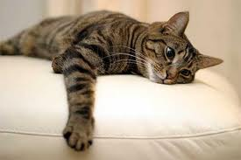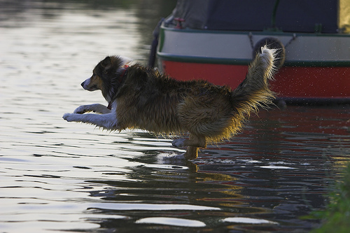

**6.** The ____________ dog jumped into **7.** The ____________ cat lies on a pillow.

the water.

SURE UNSURE SURE UNSURE

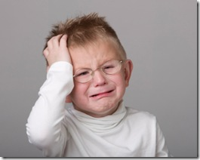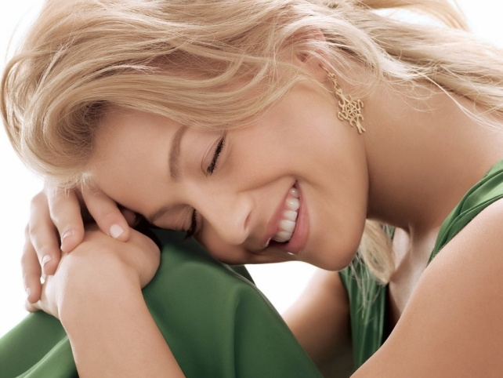

**8.** The _______________ boy is crying. **9.** The ______________ girl is sleeping.

SURE UNSURE SURE UNSURE

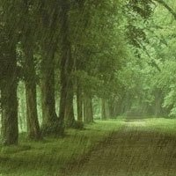

**10.** It is a _______________ day in the forest.

SURE UNSURE

**Part 2: True and False**

**Directions:** You will be given 5 statements below. Please be sure to take your time, and read each statement carefully, after reading the statement, decided whether it is TRUE or FALSE, and place an ‘X’ inside the chosen box. Don’t forget to select if you are SURE or UNSURE of each problem. ☺

**Example:**

A complete sentence does not need to have a period at the end. TRUE FALSE

SURE UNSURE

**11.** A noun is a person, place, or thing. TRUE FALSE

SURE UNSURE

**12.** A verb is a describing word. TRUE FALSE

SURE UNSURE

**13**. A complete sentence does not need to include a noun. TRUE FALSE

SURE UNSURE

**14.** An adjective is a describing word. TRUE FALSE

SURE UNSURE

**15.** A verb is an action. It is something that you “do”. TRUE FALSE

SURE UNSURE

**You’re doing GREAT…We’re almost done ☺**

**Part 3: Multiple Choice**

**Directions:** You will be given 5 Multiple Choice questions. You will read each question slowly and carefully, and then chose the answer from below that best suits the question. Please circle the answer of your choice. Also, please be sure to choose whether you were SURE or UNSURE of your answer for each question. The SURE and UNSURE portion of the question is only to help you realize what areas you can improve on at the end of the assessment. It is NOT a bad thing if you feel UNSURE. ☺

**Example:**

“_______walked across the bridge, and fell into the water”… SURE UNSURE

The blank in the sentence above should be filled with a?

1. Verb
2. Adjective
3. Noun
4. Period

**16.** A detailed complete sentence should include which of SURE UNSURE

the following?

1. Noun, Verb, and Comma
2. Verb, Adjective, and Noun
3. Noun, Question Mark, and Period
4. Verb and Adjective

**17.** What is incorrect within the sentence below? SURE UNSURE

“The dog learned to sit and stay,”

1. There should be a period instead of a comma
2. A noun is missing
3. A verb is missing
4. It is not true

**18.** “Marie ________ into work at eight o’clock this morning” SURE UNSURE

The blank in the sentence above should be filled with a?

1. Adjective
2. Noun
3. Comma
4. Verb

**Just 2 more questions ☺...**

**19.** Why is the following sentence not complete? SURE UNSURE

“The boy.”

1. There is no verb. It is not a complete sentence.
2. It is a complete sentence
3. It is wrong
4. There is no noun. It is not a complete sentence.

**20. “**The roof of the red barn shined in the bright morning sun.” SURE UNSURE

What are two adjectives in the above sentence?

1. Roof, Sun
2. The, Shined
3. Red, Bright
4. Morning, Sun

*For the feedback portion of the assessment, I would congratulate students on the completion of the assessment, and then go through the feedback portion with them while reading it aloud.

**Feedback Time!**

Now that you have successfully completed the assessment, I would like to say GOOD JOB! You all did great! Now it is time for you to give me feedback. With your help, I would like to be able to make sure that this assessment helps you the best that it can. Please answer the following questions. I will read them to you out loud first! ☺

1. Did you feel that you knew a lot about the materials covered on this assessment when you began?
2. Which questions were the easiest for you to answer? (Fill in the Blanks, True and False, or Multiple Choice)
3. What portion of the assessment did you have the hardest time on? (Fill in the Blanks, True and False, or Multiple Choice)
4. What could I do differently to help you complete this assessment?
5. Did you feel that you had enough time to complete all of the questions?

**Self Assessment**

Now that you have completed all of the questions it is time to see how you did. We are now going to go through the correct answers out loud, as a class. I would like for you to go through your answers as we do that, and mark whether you answered the questions correctly or incorrectly in the chart below (place an ‘X’ in the right box). This will allow for you to later see which sections of the assessment you should work on. Don’t forget to place an ‘X’ on SURE or UNSURE as well! ☺

|  |  |  |  |  |
| --- | --- | --- | --- | --- |
| **QUESTION** | **CORRECT** | **INCORRECT** | **SURE** | **UNSURE** |
| **1** |  |  |  |  |
| **2** |  |  |  |  |
| **3** |  |  |  |  |
| **4** |  |  |  |  |
| **5** |  |  |  |  |
| **6** |  |  |  |  |
| **7** |  |  |  |  |
| **8** |  |  |  |  |
| **9** |  |  |  |  |
| **10** |  |  |  |  |
| **11** |  |  |  |  |
| **12** |  |  |  |  |
| **13** |  |  |  |  |
| **14** |  |  |  |  |
| **15** |  |  |  |  |
| **16** |  |  |  |  |
| **17** |  |  |  |  |
| **18** |  |  |  |  |
| **19** |  |  |  |  |
| **20** |  |  |  |  |

**Putting it all Together!**

Now it is time for you to find out where you stand with our learning targets. Below is a chart that shows which questions matched up to our learning goals. Please add up the correct and incorrect answers for each section, as well as the SURE and UNSURE selections!

**Example:**

|  |  |  |  |  |  |
| --- | --- | --- | --- | --- | --- |
| **Learning Target** | **Questions** | **Correct** | **Incorrect** | **Sure** | **Unsure** |
| I can locate a complete sentence. | 13,16,17,19 | 1 | 3 | 2 | 2 |

|  |  |  |  |  |  |
| --- | --- | --- | --- | --- | --- |
| **Learning Target** | **Questions** | **Correct** | **Incorrect** | **Sure** | **Unsure** |
| I can locate a complete sentence. | 13,16,17,19 |  |  |  |  |
| I can classify the difference between verbs, nouns, and adjectives. | 11,12,14,15,  18,19,20 |  |  |  |  |
| I can recognize correct spelling. | 1,2,3,4,5 |  |  |  |  |
| I can name verbs and adjectives. | 1,2,3,4,5,6,7,8,9,10,  12,14,15,18,20 |  |  |  |  |
| I can identify errors within sentences. | 13,16,17,19 |  |  |  |  |

**What Now?**

Now it is time to break it down even more. Let’s find out what we should work on, and the areas that we know very well.

1. **What learning target(s) did you do the best in? Please circle which one.**

* I can locate a complete sentence.
* I can classify the difference of nouns, verbs, and adjectives.
* I can recognize correct spelling.
* I can name verbs and adjectives.
* I can identify errors within sentences.

1. **Which learning target(s) did you do struggle with? Please circle which one.**

* I can locate a complete sentence.
* I can classify the difference of nouns, verbs, and adjectives.
* I can recognize correct spelling.
* I can name verbs and adjectives.
* I can identify errors within sentences

1. **What can I do to help you improve in the area that you struggled with? What can you do?**
2. **Why did you feel you did so well in the area that you did the best in?**

**You did AWESOME ☺**

**Answer Key**

**Fill in the Blanks (Listening):**

1. Walked
2. Yelled
3. Skipped
4. Walked
5. Kicked

**Fill in the Blanks (Reading):**

1. Hairy
2. Striped
3. Little
4. Happy
5. Rainy

**True and False:**

1. True
2. False
3. False
4. True
5. True

**Multiple Choice:**

1. B
2. A
3. D
4. A
5. C