Around 1/23/17, we will take the summative for progress reports. Let’s practice. The summative essay question will be, “Consider the novel you read independently. How did the author use a specific motif to exude a theme?” Let’s read a text together and do the kind of reading thinking that we need in order to answer that question first.
What in infer?
Start by assessing your prior knowledge. Indicate where on the spectrum below best represents your current understanding of how to make inferences.

No idea Kinda familiar Have it mastered
Record something you DO know about infer below. “I don’t know” is the only wrong answer:

After sharing class responses, circle all of the phrases below are accurate depictions for “infer”
Literal facts from the text Predictions about events from the text What the author is implying
Reading between the lines Identifying author’s craft, like metaphor Logical guess
Synthesizing details Speculating plot events not in the text Analyzing the theme of a text
Summarizing a text Assuming what a character did when he/she was NOT in the text

After sharing answers, write your own definition of what it means to infer below:

Infer hints/tricks/tips
- Focus on subjective words: would, could, should, might, probably, hope, perhaps, assume, etc.
  - Beowulf could be feeling the pressure of being a hero to his people.
  - Chaucer might be trying to connect all of his narrators through a central theme.
  - At college, Laertes probably followed his dad’s advice and behaved in a mature manner.
- Think with the words, “I’m not sure, but I’m pretty sure…”
  - I’m not sure, but I’m pretty sure Scout Finch loves her dad, Atticus.
  - I’m not sure, but I’m pretty sure George did not want to kill Lenny, but knew he had to.
  - I’m not sure, but I’m pretty sure Beowulf would make a great dad.
- Combine what is actually IN the text and what YOU already know. This is show graphically below.

With all this in mind, amend/revise/supplement your definition of infer above.
Now try to make an inference about three or more of the stories below that you already know. Then share each with someone in class wearing the same colored clothing as you.
- Goldilocks and the Three Bears:

- The Avengers:

- The Hunger Games:

- Mr. Foster cares about your learning:

- The story of the grasshopper and the ant:

Now try it with the two pictures below. What can you infer about the two images below? Record your inferences. Share the first one with someone of the opposite gender as you. Share the second with someone who has the same favorite color as you.
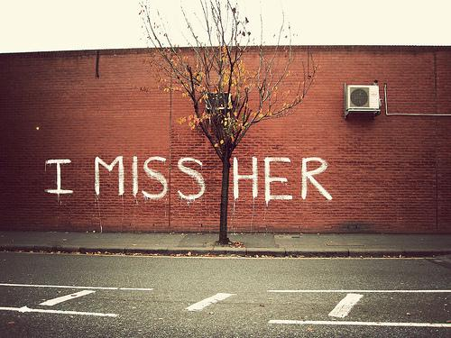

Inference

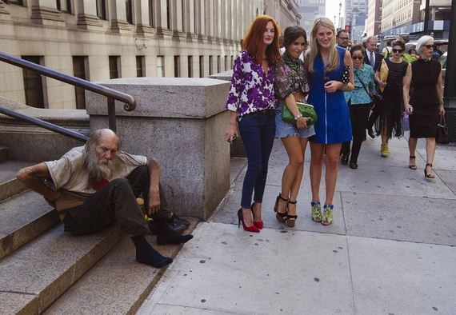

Inference

After sharing some answers, let’s try it together with a short fiction text. While reading Red with the class, record any inferences you generated. Specifically, use the infographic as inspiration and fill in the table below. Sure you can cheat and copy off someone and there will be zero numerical or disciplinary consequences. However, that is passive learning. You should know by now that it takes active learning to have success on the summative and that “failing forward” is way OK in this room.
Background Knowledge | + | Text evidence | = | Inference | Justification
Now that we know infer a little better, let’s make sure we have a better grasp on Author’s Craft.
Move to a new seat with all your stuff as a symbol or metaphor of moving to a new learning target.

See what you did there? You were just a living, breathing metaphor. You symbolized moving onto a new learning target. Symbols and metaphors are basically the same thing and are examples of kinds of author’s craft. In the space below list all other examples that you know of (for both fictional texts and non-fiction). After hearing other learners share, add to your list.

What do all of these have in common? Think, pair, share.

Yes, they all are example of author’s craft. However, they also answer the question, “How was it said?” When you read examples of author’s craft, you should recognizes and say to yourself, “Hey, that is not LITERALLY what is happening. Some kind of author’s craft is going on here.”

Now think about the story we just read, Red. What author’s craft items do you remember? Tweet your answers with specific text evidence to #fostere11. An example might be, When the author said, “the passion spread like wild fire” it was a simile because it was a direct, obvious comparison. #fostere11 Be sure to read other Foster kids tweets and “like” or “retweet” or “reply” to keep the conversation going and build your positive digital footprint.

To practice analyzing author’s craft, each day, we will listen to a song that one Foster kid will bring to class. We will analyze the lyrics to find author’s craft examples, make inferences and determine the theme of the song. This will be done in alphabetical order by last name.

One common literary technique (another name for author’s craft) is motif. Send a text message to someone in class that explains your best guess for what a motif in a text is.

As we have already discussed, the most common definition of motif is a commonly repeated idea or pattern or discussion in a text. Now think about the story we just read, Red. What do you think the most prominent motif is? Tweet your answer with specific text evidence to #fostere11. An example might be, Surrender is the most powerful motif in the story Red because multiple characters surrendered in multiple ways. #fostere11 Be sure to read other Foster kids tweets and “like” or “retweet” or “reply” to keep the conversation going and build your positive digital footprint.

Finally, what is Theme? Think for ten seconds, then shout out your answer. Then, record a three-pronged answer below. Theme is…..

Now find the person in the room that you live closest to and tell them what you think the theme of Red is.

Now that we did the reading thinking you will need for the summative, let’s do some writing thinking. This should be review and pretty darn easy. Simply fill in the blanks below to answer the summative question for the story Red.

Topic sentence

In this ____________________________________________, the author uses ____________________________________________ to
Type of text motif (you already tweeted this)

teach the reader _______________________________________________________________________________________________________.
Theme = author’s intent, universal, complete sentence

Text Evidence

This ____________________________________________ was shown in the text when the author (wrote)
motif

____________________________________________________________________________________________________________________________________
Direct words or events from the text that show the motif (you already tweeted this)

These text words are an example of ____________________________________________ because
motif

Explanation of how the words from the text depict the motif

Analysis

The theme of ________________________________________________________________________________________ is made clear through
Theme from the topic sentence

____________________________________________ because ____________________________________________________________________________
motif

This is especially clear in the text when the author _________________________________________________________________________

Therefore, ______________________________________________________________________________________________________________________.

Now on the next page, write this paragraph using strong diction & syntax. Staple this page to your inferences boxes work (page three of this document), put your name on it, and turn it in for feedback. When you get your feedback for this work, be sure to log it on Seesaw.

