Here is your chance to practice any learning targets that you think you need practice on. Your task is to basically read the article, talk to the text as you read, and then write learning target specific responses so that Mr. Foster can give you feedback. Before you begin, consult your feedback on all tasks (either on Seesaw, your paper learning targets log, and/or Powerschool) and choose which learning targets you would like to practice. Then, open the text about satire below that is appropriate for you. Then, write your response(s) and label them clearly according to learning target. Finally, fill out the single point rubric with appropriate feedback that reflects your performance on the learning targets that you chose. Please choose at least one reading and one writing learning target. After you get this response back with Mr. Foster’s feedback, log his words to continue to improve your proficiency.

“Pink” Learners: http://splitsider.com/2013/11/satire-is-hard-why-most-onion-ripoffs-dont-work/
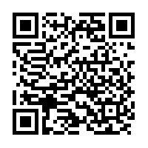

“Green” Learners: http://www.momentmag.com/how-does-satire-influence-politics/
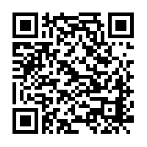

“Purple” Learners: http://arts.umich.edu/ink/2015/11/07/this-article-is-satirical/
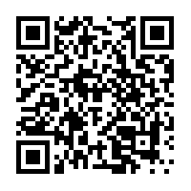

“Challenge” articles to push yourself beyond teacher’s expectations: http://exinfoam.files.wordpress.com/2010/10/the-political-effectiveness-of-late-20th-and-early-21st-century-satire.pdf and http://digitalcommons.uri.edu/cgi/viewcontent.cgi?article=1065&context=srhonorsprog

Single Point (Feedback Only) Rubric
Reading Learning Targets
Concerns | Standard | Points of Pride
Comprehension
- Explain main ideas
- Explain details
- Accurate summary
- Cite text evidence

Author’s Craft
- Accurate analysis
- Find all tricks
- Explain literary devices
- Cite text evidence
Vocabulary
- Learn new words
- Context clues
- Parts of speech
- Word parts

Theme
- Author’s message
- Complete sentence
- Moral/lesson
- Cite text evidence

Writing Learning Targets
Concerns | Standard | Points of Pride
Purpose
- Clearly answer question
- Analysis: how does evidence prove claim
- Accomplish task at hand
Support
- Abundant evidence
- Text references
- Evidence supports claim
- Relevant and accurate

Mechanics
- Follow grammar rules
- Punctuate correctly
- Possessive “S”
- Comma usage
- Spelling is clear
Style
- Word choice is precise
- Syntax is varied
- Wording is not formulaic, but unique

