Diction Practice
Here are some strong words to use in place of “good”
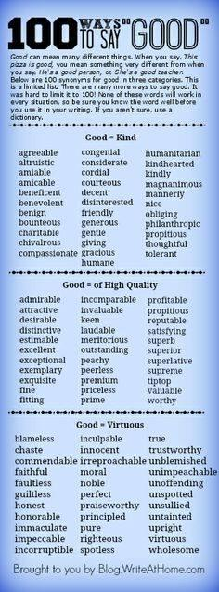
Diction Practice: List as many words as you can that are synonyms for the following words. Be sure to match the synonyms according to parts of speech

Angry hot sad happy

Small important text author

Reader theme character detail

Protagonist conflict cold showed

Evaluation: Now rank all of the synonyms that you listed by degrees of severity. For example, if under “hot,” you wrote warm, heated and scorched, you would rank them in that order. Then, share your synonyms and rankings with the partner in the room that is closest to your height.

Directions: For each numbered example, change the diction of the sentence. Make each sentence more potent, more specific, and more accurate. Paint a more vivid picture. Focus on verbs and adjectives. Feel free to add or delete phrases, clauses and words.
Example:
Old: It was a good game.
New: The game was invigorating, and it gave me a fulfilling sense of accomplishment when we won.
- The author created a sad tone.

- The things in the forest grew quickly.

- Standards Based grading is good for students; it makes them learn things.

- Spanish is a fantastic language because it is easy.

- “The Miller’s Tale” was good.

- Great teachers us fantastic teaching methods.

- Providing good feedback to bad kids that can’t learn stuff helps them get better.

Now write about any classroom appropriate topic you would like: your weekend plans, your family, the text we are reading, Mr. Foster’s amazingness, camouflage, etc. In your writing, use at least five strong adjectives, five strong verbs and three strong adverbs. Underline all of the words you used that exude mature diction.

Learning Target | 4.0 | 3.0 | 2.0 | 1.0
Style = Did I express my ideas artistically? Did I use clear, precise diction & mature, varied syntax? | I can use artistic &  accurate authorship:  specific, mature word  choice & syntax. | I can use satisfactory &  consistent authorship by  using specific words &  syntax. | I can only use  inconsistent authorship:  vague words and basic, predictable syntax. | I can only use poor  authorship: inaccurate,  immature, weak words &  syntax. I need teacher help.

